TBYC Cadet Training and Races – 1st May 2020
Briefing 13.00 Leave beach 13.30

Objective: To consider the Five Essentials

RYA’s FIVE ESSENTIALS
- Balance – side to side balance, keep flat
- Boat Trim – fore and aft boat pitch
- Sail Setting – setting of sails relative to the wind
- Centreboard – the position of the centreboard
- Course made good – choosing the most appropriate course

Rules: Rule 10: Port Starboard Rule 18: Mark Room

Briefing: 10.30– an explanation of today’s exercises on the beach
SOCIAL DISTANCING essential
11.00 – on the water
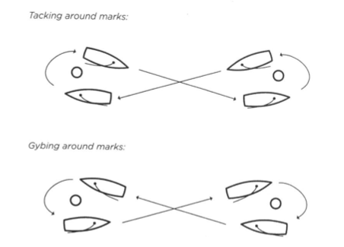
Warm up
‘Start line’ reach - sail in a ‘Figure of Eight’.

Repeated until everyone has arrived and warm.

Tacking then Gybing

Rules: Port/Starboard and Mark room

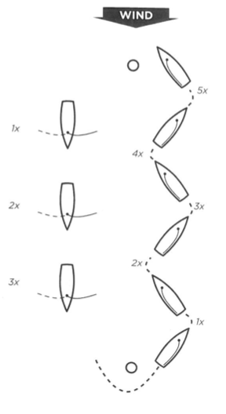
Windward / Leeward

Tacking / Gybing on the whistle

Starts

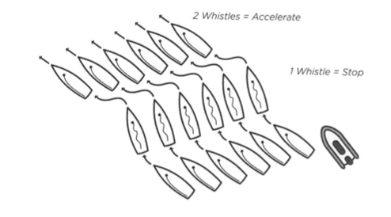
Stop / start on whistle

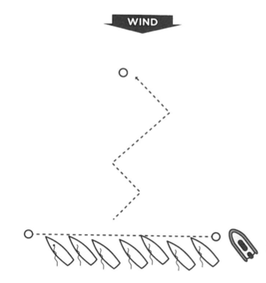
Starts 1-minute warning

2 starts only until whistle (20 metres)

3rd Start to Windward buoy

Three Races

Triangle course – two laps

Leave marks to port, finish through line to windward.

3 minute warning from Displacement ‘Polly’ boat. Watch the flags.

Rules: Port/Starboard and Mark room.

De-briefing 40 minutes after last boat to arrive back at the beach. Meet in the Dinghy Park by small rib hut.

